Java 8 Features: https://github.com/dilipsundarraj1/java-8
Functional Programming: We can create a function and assign the functionality to a variable and pass it as method parameter
Lambda Expression: Functions without any name/ anonymous function, can be passed as parameter and used anywhere
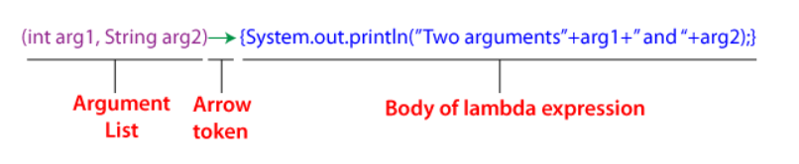
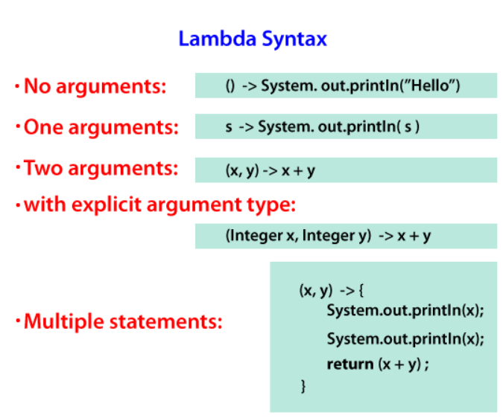
Functional Interface: Interface with exactly single abstract method, it can have default and static methods.
Custom Function Interface can be created by @FunctionalInterface
Ex: Runnable run() method, Callable call() method and Comparable compareTo() method and ActiveListener actionPerformed() methods Comparator compare() are built in Function Interfaces
Uses single abstract method and reduces the boiler plate code.
Function: It accepts only one argument and returns a specified result
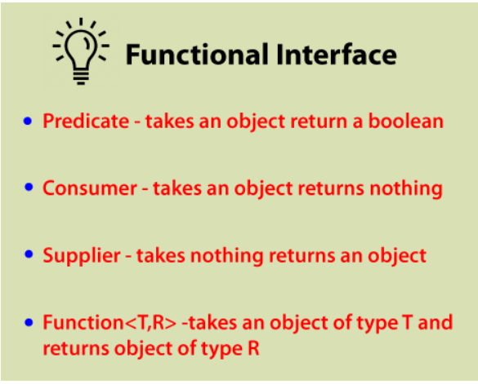
Method Reference: Uses the function to refer a method inside the class. Compact way of referring to method of single abstract method provides simple and readable code.
ClassName :: MethodName
Types of Method Reference:
Static Method Reference: It is used to refer to static methods from a class.
ClassName:: StaticMethodName
Reference to an Instance Method: It is used to refer to an instance method using a reference to the provided object and by anonymous object.
ObjectName:: methodName
Reference to a Constructor: It is used to refer to a constructor using the new keyword. It references to a constructor can also be done with the assistance of a functional interface.
className::new
Static and Default Methods: It provides an implementation of methods within interfaces enabling 'Interface evolution' facilities / enhance interface functionalities.
default keyword in method signature. If the default method is added to an interface, we no need to implement it in the implementing classes compulsorily. And implementation can be added in interface. Can override the default method - To override we should not use the default keyword and create a method in implementing class with same method signature.
Order of method call during run time for default methods.
- Class that implements the interface
- The sub interface that extends the interface
- If two interface have same default methods with different implementation we need to override the method to the implementation class(without default keyword) and runtime method resolution will invoke the method present in the implementation class
static keyword in method signature. If the static method is added to an interface, we can call the method using the Interface name. Cannot override the static method as its class level. Used for utility methods or helper methods for default methods.
Stream API: Abstract layer that provides pipeline processing of the data.
Stream: Sequence of object, perform series of operations like Unix pipeline (|). Cannot access or modify once steam is constructed, traversed only once and lazily constructed and perform internal iteration.
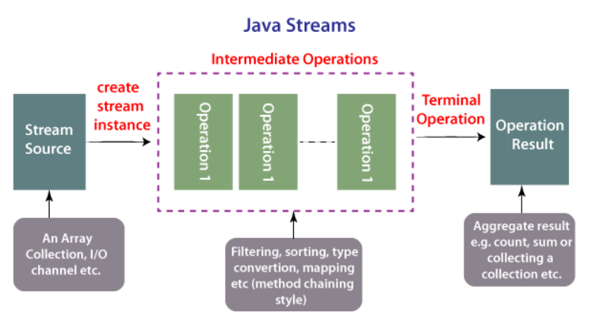
Types of Stream Operations:
Intermediate: Transforms stream to another stream, does internal iteration of all the elements.
Terminal: Kick-starts the Stream pipeline and used to collect the processed Stream data
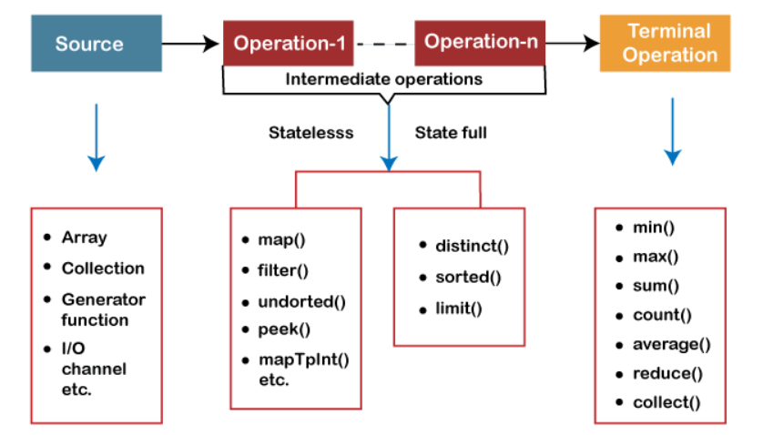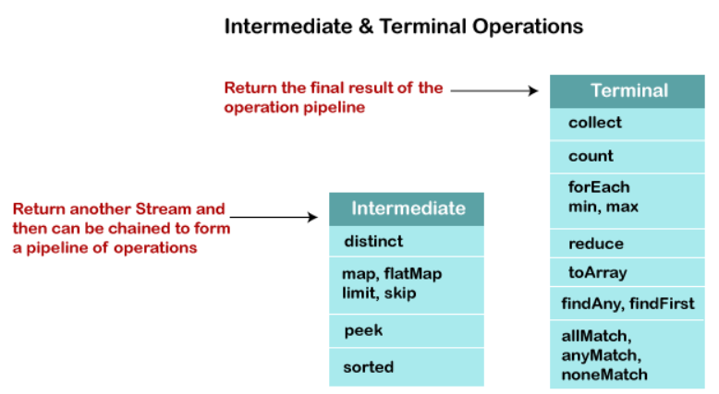
Intermediate Operations:
map(): Convert/transfer one type to another(Ex: Stream of Object to Stream of String)
flatMap(): Convert/transfer one type to another. Used in context of stream where each element in stream represents multiple elements(List of List).
distinct(): Returns a stream of unique elements
count(): Returns a long with total number of element in a stream
sort(): Sort the elements in a stream
filter(): Filter the elements in the stream with respect to the condition. Input to filter method is a predicate functional interface.
Terminal Operations:
reduce(): Reduce the content of stream to a single value. Takes two arguments initial or default value and BinaryOperator<T>
collect(): collect the content of stream to a collections type. Takes one argument as type in form of of collections and convert the steam to the specific type.
min() and max(): returns min and max value from the stream
limit(n): Limit the n number of the elements to be processed in the stream.
skip(n): skip the n number of the elements to be processed in the stream.
anyMatch(): Returns true if one element matches the predicate or false
allMatch(): Returns true all element matches the predicate or false
noneMatch(): Returns true no element matches the predicate or false
findFirst(): Returns first element in the stream
findAny(): Returns the first encountered element in the stream
peek(): Used to debug in streams pipeline. Returns a new Stream consisting of all the elements from the original Stream after applying a given Consumer action
Factory Methods:
of(): Create the stream with the certain values passed.
iterate() and generate(): Used to create infinite streams
Parallel Streams: Split source of data in to multiple parts and process them parallelly and give the combined result.
DateTime API: Abstract layer that provides pipeline processing of the data.
Optional: Wrapper class to check the null values and helps in further processing based on the value.
Avoids null pointer exception and unnecessary null checks
Nashorn: A JavaScript Engine: Nashorn is a devised variant of JavaScript Engine introduced in Java SE 8 that provides JavaScript performances in Java to succeed Rhino.
PermGen and MetaSpace:
PremGen: MetaData information of classes was stored in PremGen (Permanent-Generation) memory type before Java 8. PremGen is fixed in size and cannot be dynamically resized. It was a contiguous Java Heap Memory.
MetaSpace: Java 8 stores the MetaData of classes in native memory called 'MetaSpace'. It is not a contiguous Heap Memory and hence can be grown dynamically which helps to overcome the size constraints. This improves the garbage collection, auto-tuning, and de-allocation of metadata.
HashMap Improvement in Java 8: Buckets containing the larger number of colliding keys will store the entries in a balanced tree instead of LinkedList once the threshold is reached.
Functional Interface Inherit/extend another interface:
- It should not extend the other interface abstract methods because it will break the SAM rule.
- It can extend the other interface default, static and normal methods because it will not break the SAM rule
Why Functional Interface has only one method and relationship between lambda?
A functional interface in Java has only one method because it is designed to be used with lambda expressions, which can only represent a single function with a specific set of inputs and outputs; therefore, restricting the interface to a single abstract method allows for a clear mapping between the lambda expression and the interface's functionality.
Can Functional Interface have default and static methods?
Yes, functional interfaces in Java can have default and static methods. Functional interfaces are interfaces that have only one abstract method, but can have any number of default and static methods.
Can use string and enum in switch case as before jdk 8 we can use only int
Java 9 Features:
Try with resourses can handle final variables declared in the try block.
Private methods in interface(with version diff) - https://www.geeksforgeeks.org/private-methods-java-9-interfaces/
Java 10 and 11 Features:
Local Variable Type Inference allows the compiler to infer the type of a local variable based on its initializer, reducing the need for explicit type declarations
Uses of var: Used as localvariable after initialization, Used as localvariable in lambda functions, static/instance initialization block, iteration variable in enhanced for-loop and conventional for loop, return value from anothor method to return value in method.
Restrictions of var: It cannot be used for method parameters, return types, class fields, uninitialized variables or variable initialized with ‘NULL’.
Java 12 features:
Indent(Added or removes intent with the input given) and transform(used to transform string with functional programming)
File mismatch method: it is used to compare the content of two files for differences without reading the entire file.
Switch case: Can return values from a switch block and hence switch statements became switch expressions. Use multiple labels and return using break, yeild keyword(JDK 13 and 14) or arrow operator.
Java 14 features:
instanseOf method: Used to determine if an object is an instance of a particular class, subclass, or interface. It returns a boolean value
Java 16 features:
Record class: Special type of class designed to concisely model immutable data(final variables by default). They reduce boilerplate code typically associated with data carrier classes (POJOs or DTOs)
It cannot extends a class. But it can extend a record or implement an interface. We can create methods, static methods and variables. And cannot create instance variables it needs to be done while declaration.
Java 17 features:
Switch case: Use patten/guarded patten and null cases can be checked
Sealed class: Sealed classes and interfaces restrict which other classes or interfaces may extend or implement them. Sub class inheriting the sealed class can be sealed, non-sealed or final.
Java 21 features:
Virtual Threads:
String Templates: Used to create template expressions that can be rendered into strings. resolves the injection issues with strings.

Sequence Collections: Provides utility methods add the element in first and last, reverse and some sequence methods to enhance collections.

